**WARP BOARD TUTORIAL**

1. Open IMPACT 14.4 (a Xylinx tool) from the desktop. It is highlighted in the below given picture.



2. You will get a screen as shown below. Open drop down menu ‘Output’ from the menu bar and select Cable Setup…

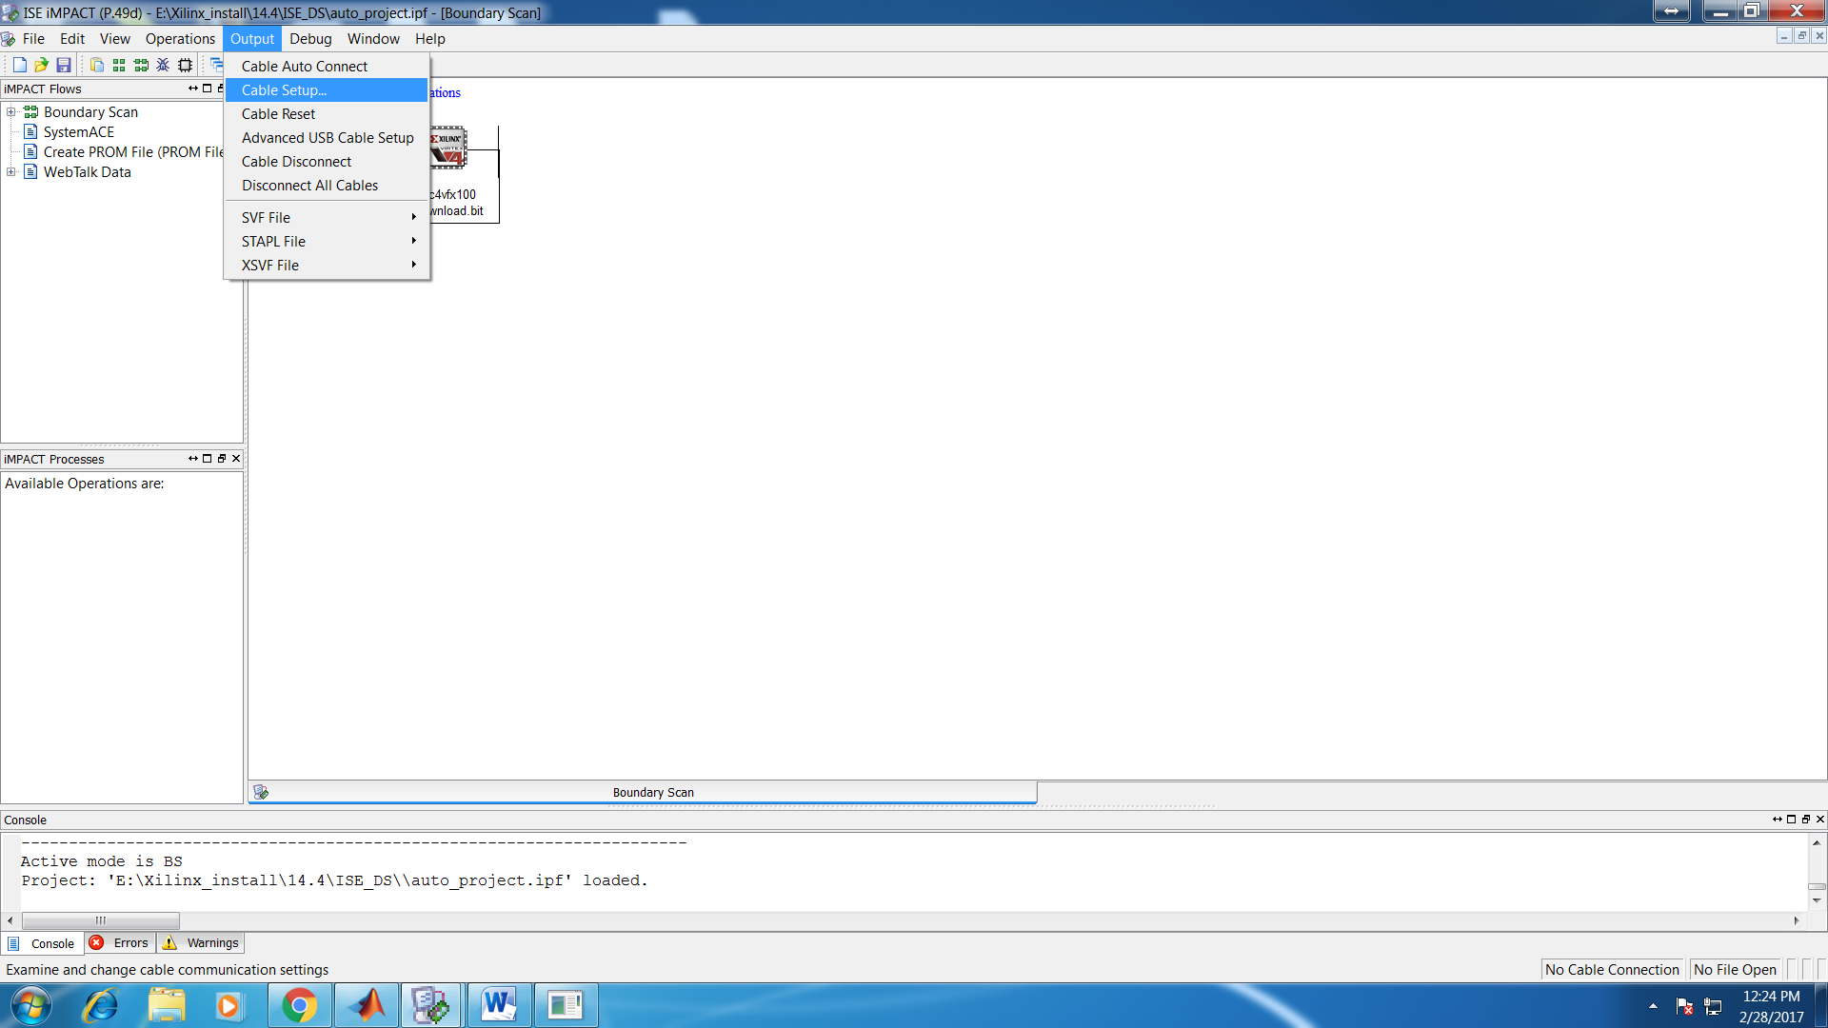

3. Select Platform Cable USB/II for board with IP 10.0.0.4 and press OK.

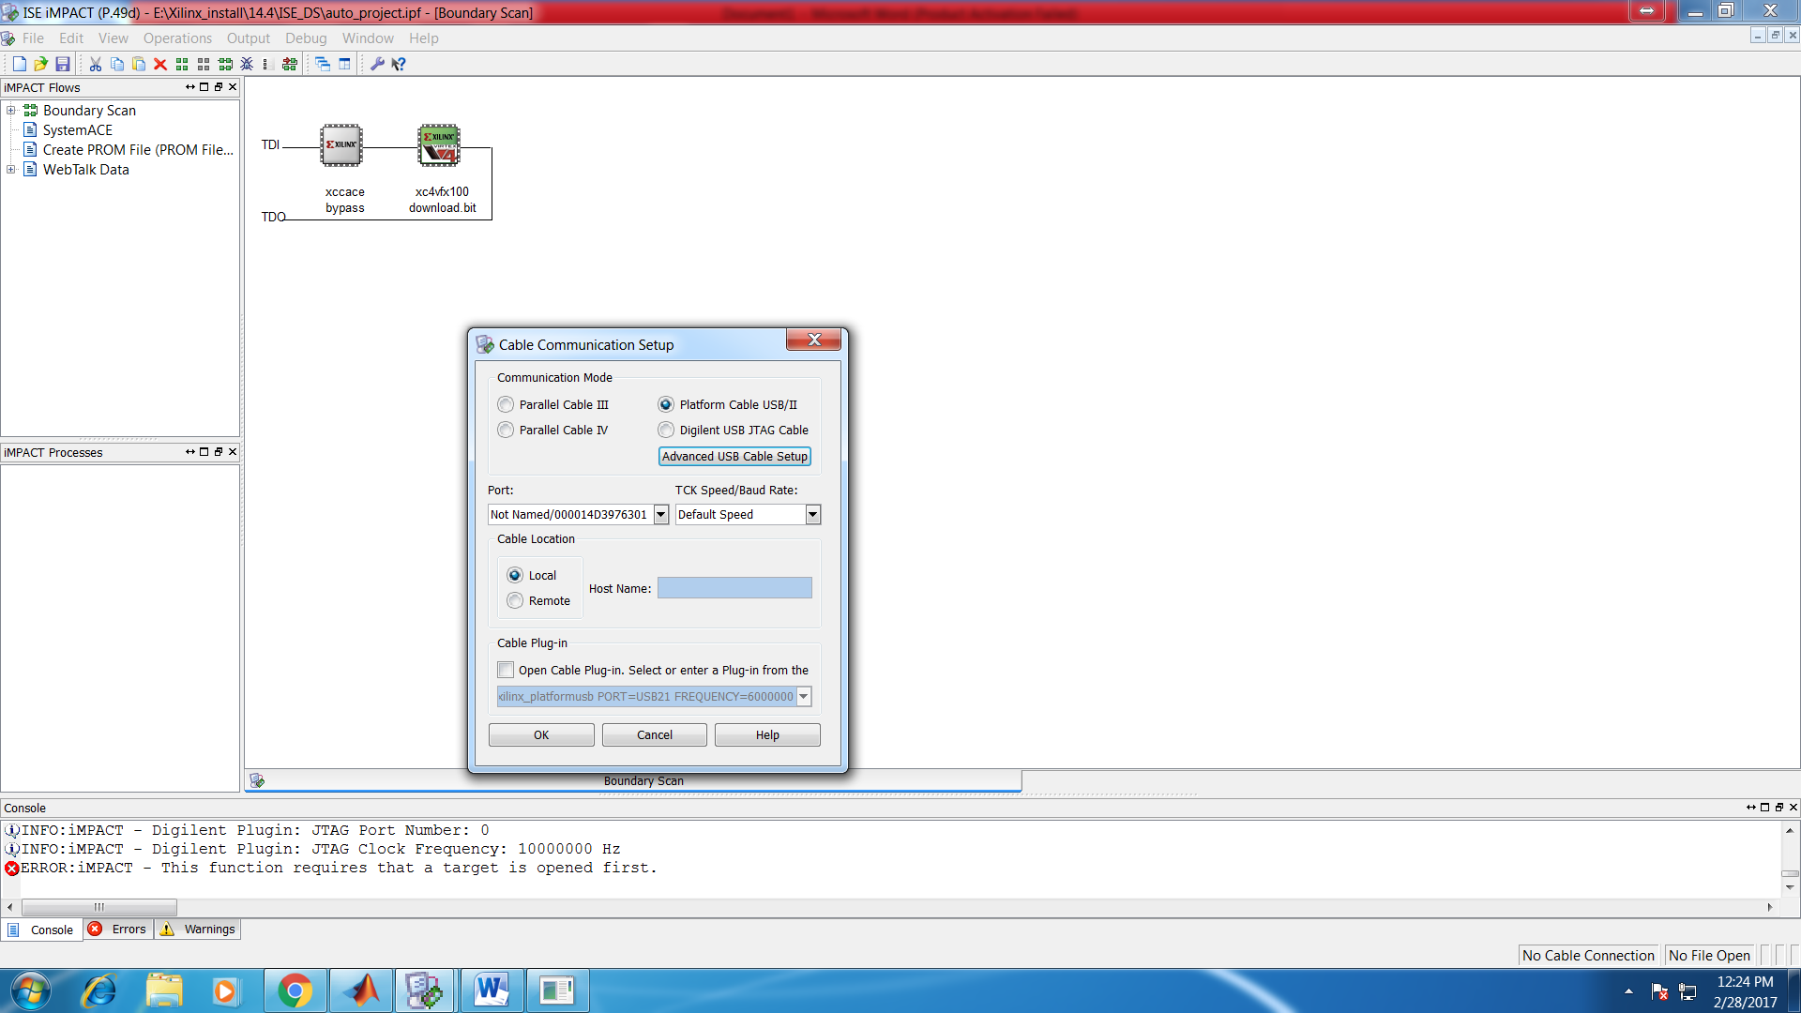

4. Right click on the FPGA block (half green in colour) and click on program.

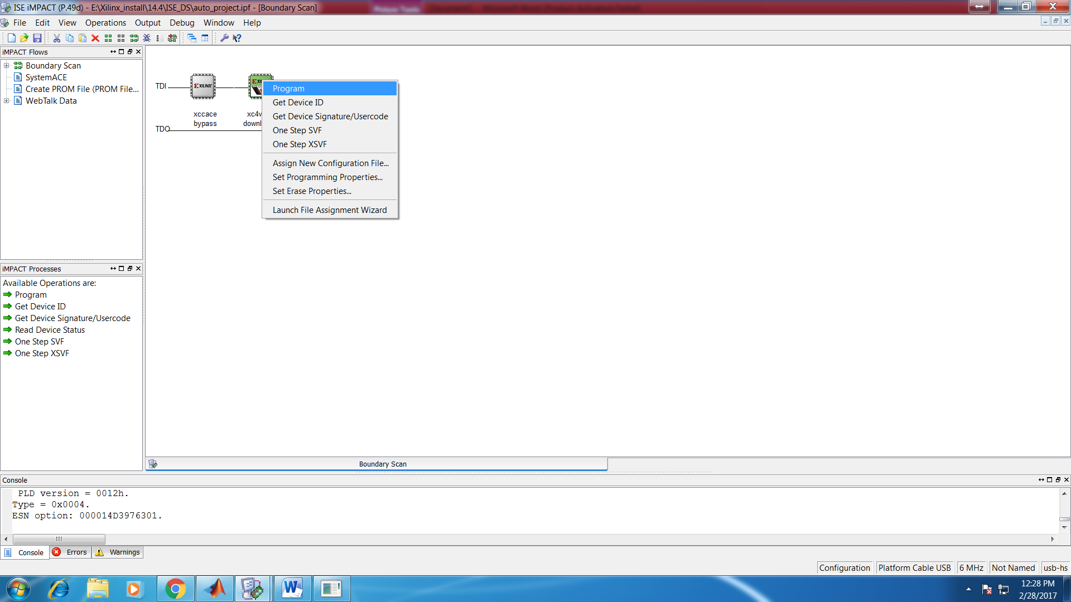

5. Program Succeeded message indicates bitstream has been loaded into the FPGA and board will show ‘04’ on LED display. This means IP address 10.0.0.4 has been assigned to the board.

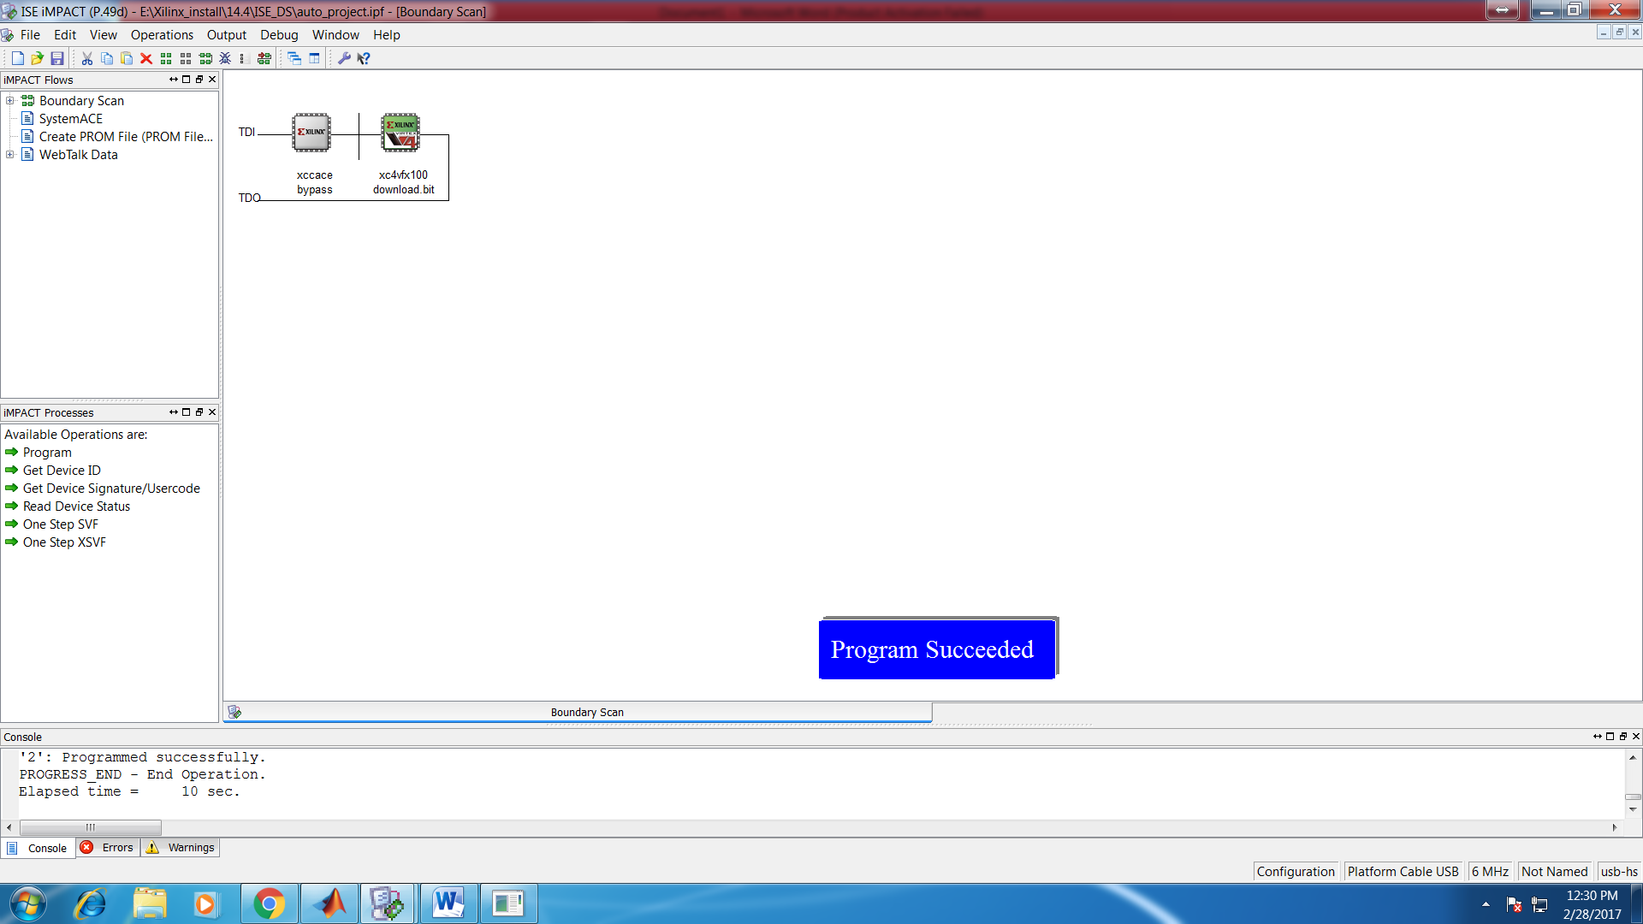

6. Minimize IMPACT window and open MATLAB. Open script GSM_tx.m. Assign your I Q data to transmit buffer of board by putting Node1_Radio2_TxData equal to the array (declared by you) contacting IQ complex values.

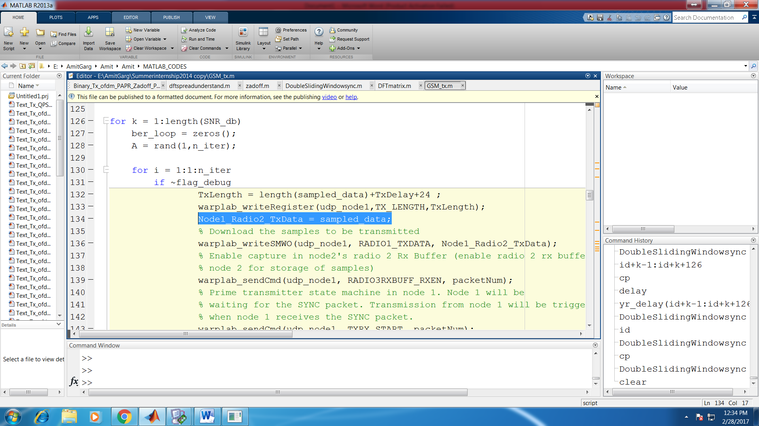

7. IQ complex values received after passing through the channel will be available in Node1_Radio3_RxData. Copy this data into an array, declared by you, for further receiver side processing.

